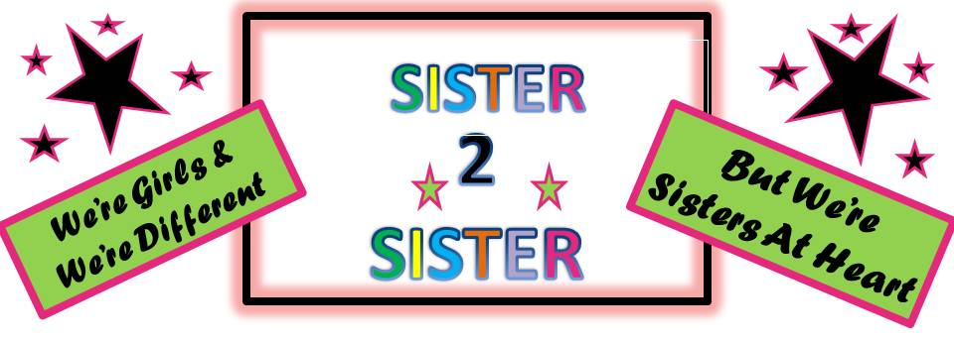

The Sister 2 Sister event will be held on Saturday, March 19, 2011, from 9:30am-3:30pm at UMASS Dartmouth, Woodland Commons, located at 285 Old Westport Rd, N Dartmouth. Parking in Lot #7. The fee of $25.00 includes all activities for the day and lunch. Please return fee and application together. Scholarships available for qualifying girls.

Name:___________________________________________Age:__________________

School:________________________________________________________________

Parent/Guardian Name:___________________________________________________

Address:_______________________________________________________________

Home Phone Number:____________________________Cell:____________________

Emergency Contact:___________________________Phone Number:______________

Allergies/Health Conditions:________________________________________________

Are you applying for a scholarship? Yes________No________

Anything else we need to know:____________________________________________

I grant permission for _______________________to attend the Sister 2 Sister Program
Child’s Name

____________________________________________________________________
Parent/Guardian Signature Date
(If transportation is an issue, please call 508 999-3255)

PLEASE PICK THE TOP 4 TOPICS YOU ARE INTERESTED IN AND RANK THEM FROM 1 TO 4

- Body Image ___________

- Bullying ___________

- Career ___________

- College ___________

- Health ___________

- Video games ___________

- Social Media ___________

- Girl Friendships ___________

- Dating/Relationships ___________

- Diversity ___________

- Making a Difference ___________

- Anything Else ______________________________________________

Please return with payment by March 7 to:

Sister 2 Sister/YWCA Southeastern Massachusetts
20 South Sixth St
New Bedford, MA 02740

